The Application of Android System: Obtaining LBS Information from Mobile Phone

### Jiawei XU

Academic Supervisor: Pierre MARET

Industrial Tutor: Cai JIAN

### 17 June, 2019

**Contents**

1 Introduction 3

2 Company Presentation 4

2.1 General Presentation of Ping An Group 4

2.2 OneConnect Company and its Activities 4

2.3 Insurance Intelligent Risk Control Laboratory 6

3 Presentation of Context and Problem 7

3.1 Why do we need the LBS information? 8

3.2 Why do we need the Android application? 8

3.3 Why do we need the Local Server? 8

3.4 Why do we need the Gaode Map SDK? 9

3.5 What are the difficulties? 9

4 Solution and its Steps 10

5 Implementation of the Solution 12

5.1 Build Android application demo 12

5.2 Build the Local Server 14

5.3 Connection between Android application and the Local Server 15

5.4 Use Gaode Map’s SDK in Android application 16

5.5 Debug and Refine Android application 18

5.6 Result 19

6 Test and Status of in-use 20

6.1 Test 20

6.2 Status of in-use 21

7 Conclusion 23

7.1 About what I've done and will do 23

7.2 About what I have learnt except for working experience 23

References 25

# Introduction

The first topic of this internship is a demo of the future product of OneConnect company. This product is based on the historical location information obtained from the user. My company’s work is to process the location information with specific data analysis algorithms to get the user's geographic location label, such as living location, work location, hometown, commuting mode. Then, based on the latest location information, it can send the recommended stores information to users by Mobile SMS or Software Notification (such as restaurants, shopping malls and entertainment places).

My part is to use Android development technology to make an Android application. This Application could get the LBS (Location Based Service) information of the phone. Also, I used some Map jar of Gaode Map as Android Application’s library. Therefore, this application could show the heat Map of phone’s LBS information on a digital Map. In order to make this Android application, I need study and use the knowledge of Android’s Google Location Service [6], the life cycle of Activity [5], local Server, and Gaode Map SDK.

The final goal is to make an Android application which could run on an Android phone (min API level: 23) and build a local server based on a laptop. This application gets phone’s LBS information 10 minutes once time, then save these information as a text file with a fixed format in this phone’s memory. Upload this file from phone’s memory to the local server’s memory space (in somewhere of the computer’s memory), other computer which connect to same Local Area Network (for example: WIFI or Phone’s Hotspot) with this local server could visit and download these files.

# Company Presentation

## General Presentation of Ping An Group

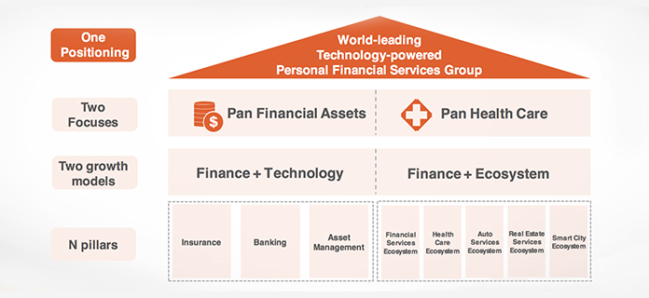

Figure 1: The Strategy of Ping An Group

Ping An Insurance (Group) Company of China, Ltd. was established in Shenzhen City, in 1988. It has developed into a personal financial services group with three core businesses: insurance, banking and investment, enjoying parallel growth of its core finance and internet finance businesses. The Group’s shares are listed on the Stock Exchange of Hong Kong and Shanghai Stock Exchange [11].

Ping An is focusing on "big financial assets" and "big health care". It pursues growth in insurance, banking, asset management, and internet finance and provides customers with an excellent experience. Ping An Group is a world-leading technology-powered private financial service group. With 184 million customers and 538 million Internet users, Ping An is one of the world’s largest comprehensive financial service company. Ping An has over 1,600,000 employees and life insurance sales agents. As at December 31, 2018, the Group had USD 1.04 trillion in total assets. In the 2018 Fortune Global 500 list, Ping An ranks No. 29 among all the companies [11].

## OneConnect Company and its Activities

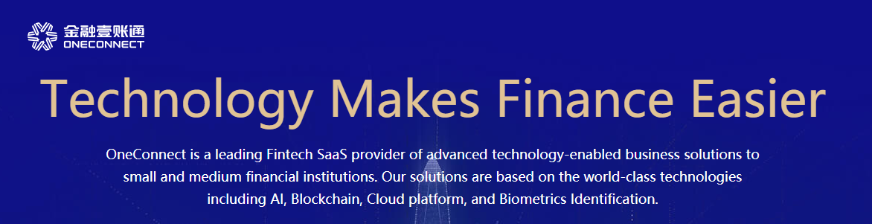

Figure 2: The Slogan and Introduction of OneConnect company

OneConnect company, the world's leading technology service platform covering the whole financial industrial chain, is an associate company of the Ping An Insurance Company of China, Ltd. It was registered and founded in December 2015 [12].

As an important player practicing Ping An Group's "finance + technology" dual-drive strategy, OneConnect provides financial institutions with end-to-end solutions, such as smart marketing, products, risk management and operations. The Company helps financial institutions increase income, improve efficiency and services, and reduce costs and risks. Therefore, they can be transformed towards smart finance. In the end of March 2019, OneConnect has served over 3,300 financial institutions, including nearly 600 banks, over 70 insurance companies, and more than 2,600 other non-bank financial institutions [12].

OneConnect is a global leader in AI, biometrics, blockchain and other fields. By the end of March 2019, there have been more than 2,200 patent applications by OneConnect at home and abroad, of which 98% were invention patent applications. The Company has a strong R&D team consisted of members from the global leading universities and companies. Researchers account for 46% of all employees. OneConnect has established research institutions and branches in China, the United States, Singapore and other countries. Its technological strength has been recognized by domestic and foreign authoritative organizations [12].

The Company completed the Series A funding in early 2018, with a valuation at USD 7.5 billon.

Main Business Sections: SME Financing Service Platform, Asset Management Platform, Oxygen Molecule Platform, FiMAX, SaaS Cloud Platform and Business Advisory

•

Four Core Technologies: AI, Blockchain, Cloud Platform and Biometric Identification

•

Five Powerful Tools: Digital Sales Solutions, Digital Risk Management Solutions, Digital Product Solutions, Digital Service Solutions and Digital Operation Solutions

•

•

Five Promotion: Increased Customers, Reduced Risk, Diversified Products, Optimized Service and Efficient Operation

•

## Insurance Intelligent Risk Control Laboratory

On January 31, 2018, The Insurance Institute of China and The OneConnect Company co-sponsored the establishment of "Insurance Intelligent Risk Control Laboratory" to jointly build an intelligent platform for insurance wind control research and practice. This Laboratory conducts comprehensive research and promotion activities on insurance anti-fraud and anti-leakage, organizes a forum on insurance anti-fraud, anti-leakage risk, insurance peak, further improves the level of research on insurance risk prevention and control in China.

Under the guidance of the Chinese Insurance Society and with the support of the "Intelligent Insurance Cloud" technology of financial one-account communication, the "Insurance Intelligent Risk Control Laboratory" has studied and established an intelligent anti-fraud system of multi-types of insurance, giving full play to the technical advantages of big data, artificial intelligence and cloud computing, and providing support for the analysis and early warning monitoring of fraud risk in insurance industry.

# Presentation of Context and Problem

In my department, there are already some successful products based on geographical location.

For example, the Department has developed a region-based product “Suo You Ge” (means All the regions in Chinese). This product is based on information about a region in the city. Process the information to get some labels of this region, such as shopping level, restaurant level. Many banks and insurance institutions are interested in these labels:

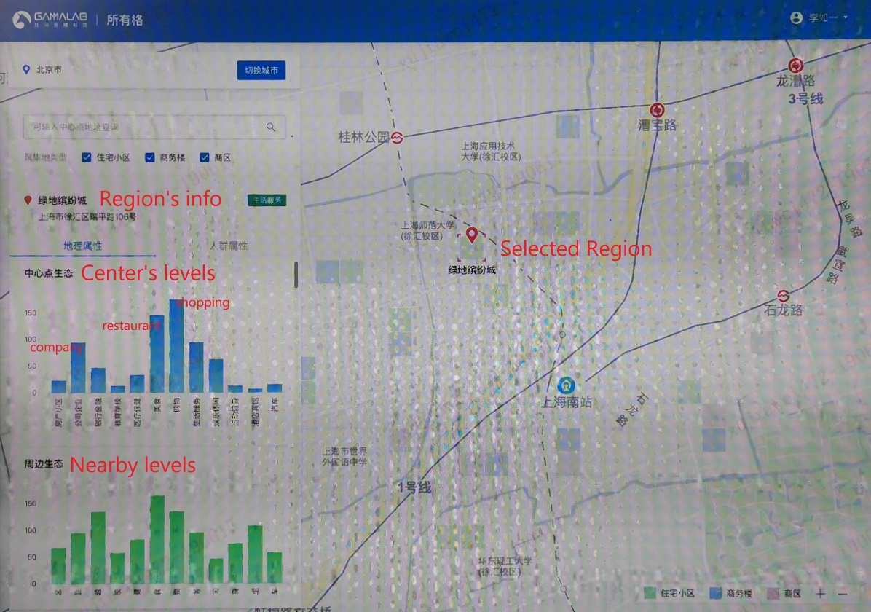

Figure 3: The Product Effects of “Suo You Ge”

However, this product could not provide banks or insurance institutions these labels which are based on their customers’ personal information.

Therefore, we're trying to implement a new product for banks and insurance institutions. This product could provide some useful labels and consumer recommendations. These labels and recommendations are obtained after processed users’ personal location information record.

Here are predicted results of this product:

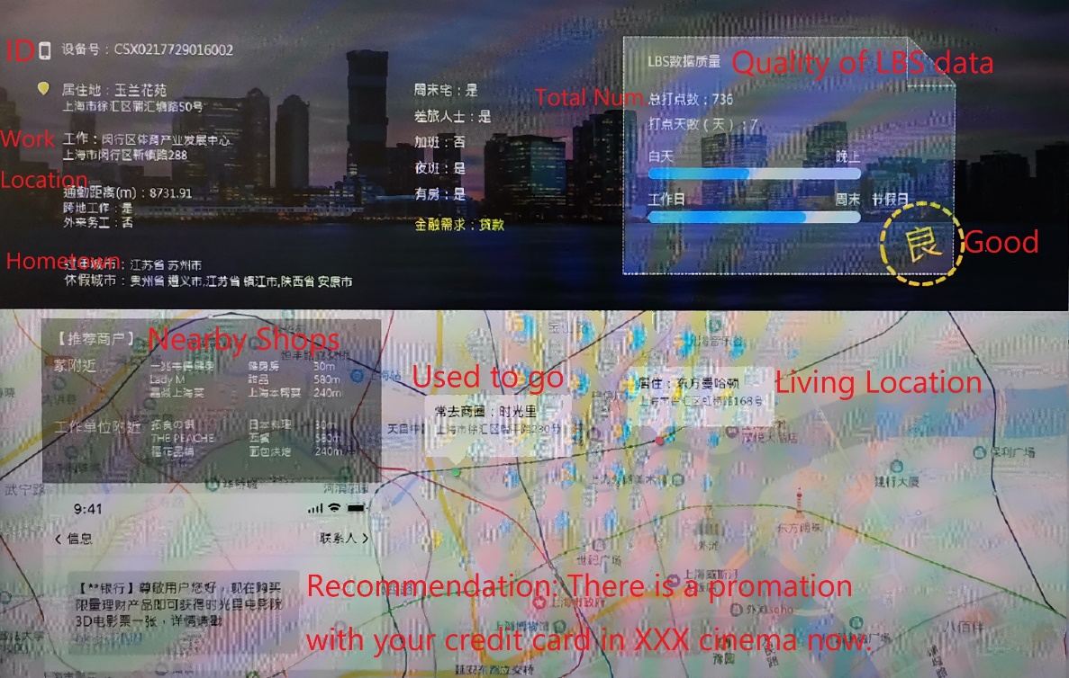

Figure 4: The Effects of future Product

## Why do we need the LBS information?

For our future product, we need to acquire a lot of location information of an individual user. Therefore, we could use specific data analysis algorithms to process these data and get some useful labels. For example, we use clustering analysis algorithm to get the workplace.

## Why do we need the Android application?

We want to use a single version application at the beginning. According to a survey report, Android share for 2018 was 85.1% and is expected to increase slightly in 2019 at 85.9% [13].

Besides, I have studied and used the Java language and have some basic acknowledge of Android application development.

## Why do we need the Local Server?

We need to do a presentation to the leader of department and participate in an internal competition of our company in July 2019. And because of the company's rules and regulations, our official computers have some restrictions on access to some cloud services. Therefore, Tomcat is used in this project as the local server solution to ensure that the final project demonstration process is stable.

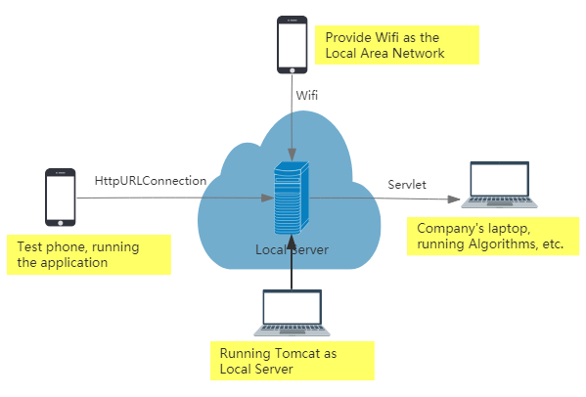

Figure 5: The diagrammatic sketch of Project presentation

## Why do we need the Gaode Map SDK?

According to the idea of software product manager, it is necessary to add data visualization display part in this application. It is decided to use the open source SDK of Gaode Map, which has a high market share in China.

## What are the difficulties?

1. Product requirements are not clear enough at the beginning and need to be modified according to the effect in the process of implementation.
2. Because many websites such as Google can not be visited in China, it is inconvenient to learn relevant technologies in English.
3. I have very little experience in Android development. I need to systematically learn relevant theoretical knowledge and technology. Also, I need to be familiar with Android development tools: Android Studio [10] at first.

# Solution and its Steps

To meet these needs, after discussion with product managers, project algorithm engineers, Android engineers in other departments, front-end engineers, back-end engineers and database engineers, we decided to adopt “Android Application (develope on Android Studio) + Tomcat (local server) + Gaode Map SDk” as the final solution.

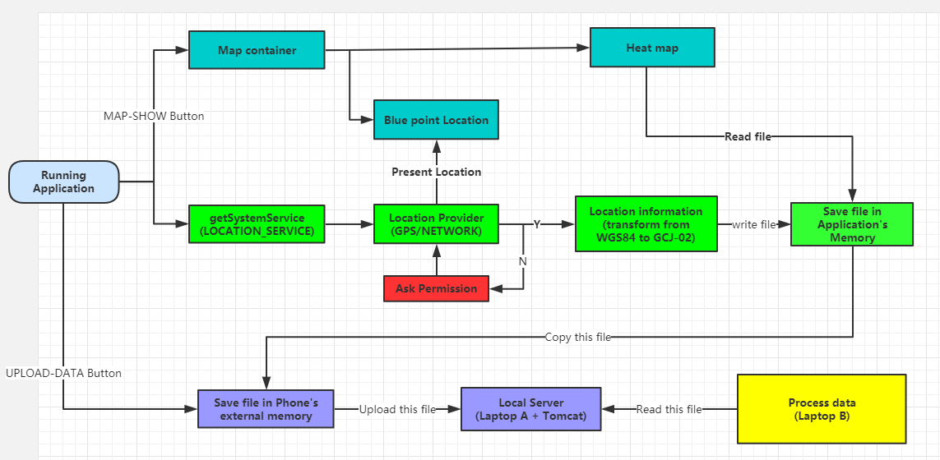

Figure 6: The logic diagram of Android application system [9]

Android Studio is an integrated Android development tool developed by Google. Based on IntelliJ IDEA. Like Eclipse ADT, Android Studio provides an integrated Android development tool, which can be used for Android Application development and debugging [10].

Tomcat server is a free open source Web lightweight application server. In fact, Tomcat is an extension of Apache server, but it runs independently at run time. When you run tomcat, it runs as a separate process from Apache [14].

Gaode Map API/SDK is a set of map application program interfaces for developers, including JavaScript, iOS, Andriod, Windows, static Maps, Web services and other versions. It provides rich functions, such as location, Map, navigation (bus/drive/walk), location search, peripheral search, geocoding and inverse geocoding, real-time road conditions [15].

Considering the progress requirements of the project, it is decided to implement Android Application development in the following steps:

1. Build Android application demo.
2. Build the Local Server.
3. Connection between Android application and the Local Server.
4. Use Gaode Map’s SDK in Android application.
5. Debug and Refine Android application.
6. Result and simple Test.

The future version of this application is to put these functions into an Android SDK and provide this SDK to my company's customers. Small and medium-sized banks are more interested in these location labels. They could use this SDK in their own mobile bank applications, then these applications upload the location information to my company’s data base and get location labels as return:

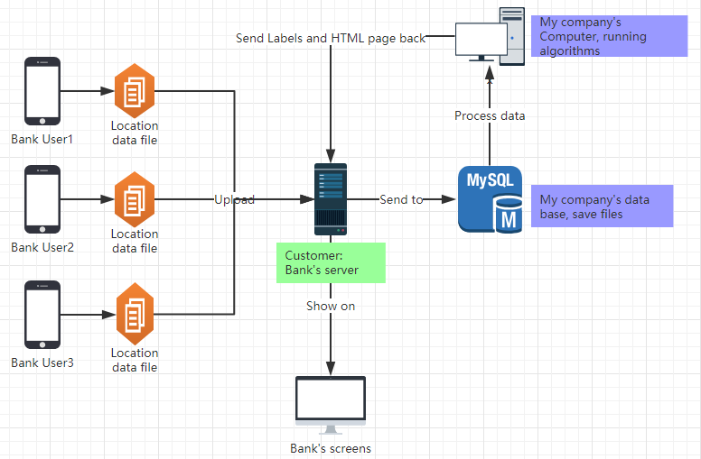

Figure 7: The diagrammatic sketch of future Product

# Implementation of the Solution

## Build Android application demo

Android system provides APIs related to geographic location services to facilitate developers to access the current geographic location.

Location Manager: Be used to obtain latitude and longitude information of geographic location.

Location Providers：A set of components that provide positioning functions. Each component in the set provides the current location of the device with different technologies. The difference lies in the accuracy, speed and cost of positioning, etc.

1. Get Location Manager can be obtained by calling the android. app. Activity. getSystemService () function:



1. Get all available location providers:



1. GPS_PROVIDER: Obtain longitude and latitude information of geographical position by GPS:



Advantages: high accuracy of geographic location information acquisition;

Disadvantage: It can only be used outdoors. It takes time and power to obtain longitude and latitude information.

1. NETWORK_PROVIDER: Geographical location can be obtained by base station or Wi-Fi of mobile network



Advantages: As long as there is a network, it can quickly locate, indoor and outdoor can be;

Disadvantage: low accuracy.

(3) PASSIVE_PROVIDER: Passively receives updated geographic location information without requesting geographic location information by oneself. The location returned by PASSIVE_PROVIDER is generated by other providers. The getProvider () method can be queried to determine the origin of location updates. ACCESS_FINE_LOCATION authority is required, but if GPS is not enabled, this provider may only return a rough location match.

1. Judge whether the available location providers are network positioning or GPS positioning, if not, then jump to the setting interface and prompt to open the network and GPS positioning services:

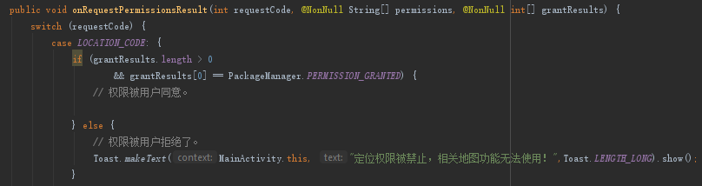

1. Obtain Location. Here we get the internationally recognized WGS84 coordinate system [2]. It needs to be transformed into GCJ-02 longitude and latitude coordinate system used in Gaode Map (coordinate system issued by China National Bureau of Surveying and Mapping in 2002):



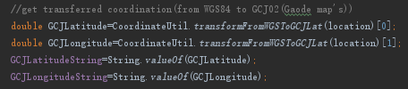

1. Monitor changes, according to geographical location or time: Here set up 10 minutes to monitor once time:



1. Store location information record in TXT file of the application’s. Then copy this file from the application’s memory to the phone’s external memory, which enables the algorithm engineer to obtain the location information data files in advance:

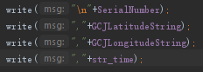



1. Complete the layout of the main page of the program, including text display and buttons.

Note: Above Android API Level 23, need to write code in Android Mainfest. XML to get dynamic loading permission. Give the software high priority of background operation. Therefore, the software can get the location information on time as far as possible [6].

When the Android program is developed, it runs on the test mobile phone for a week and gets about 500 location information records. The file is sent to the algorithm engineer through the mobile phone mailbox, and the algorithm engineer begins to process the data with the algorithm that has been done, then observes the results. This can not only improve the algorithm in advance, but also give suggestions on the location information format and other functions.

## Build the Local Server

Tomcat is a Web application server and a Servlet/JSP container. As a Servlet container, Tomcat handles client requests, transmits requests to Servlets, and transmits the response of Servlets back to clients. Servlets are components running on servers that support Java language. The most common use of Servlets is to extend the functions of Java Web servers, which are very secure, portable and easy to use [8][14].

1. Install and configure Eclipse Java EE IDE for Web Developers:

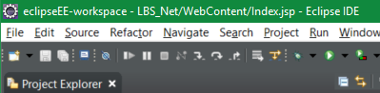

1. Install and configure Tomcat v8.5.4:

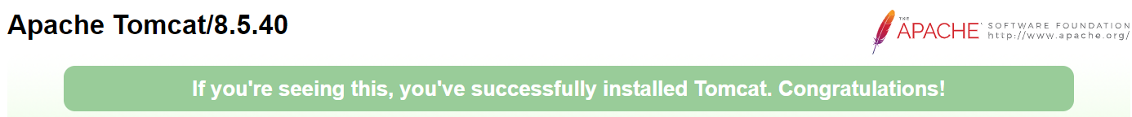

1. Create Web project:

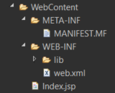

1. Code implementation of servlet server:

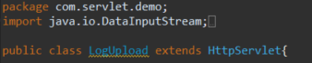

1. Generate .war file and copy it to the local folder web apps of Tomcat server:

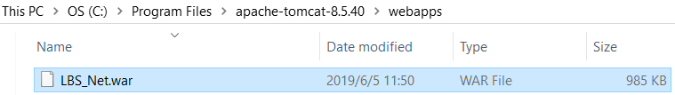

## Connection between Android application and the Local Server

Network request is one of the most commonly used operations in Android development [3]. HTTP (Hypertext Transfer Protocol) is also well supported in Android SDK, which includes two interfaces:

The standard Java interface (java. NET) - HttpURLConnection can realize simple URL-based request and response functions;

Apache interface (org. appache. http) - HttpClient, which is more powerful to use. (But, from the SDK of Android API Level 23, Google removed HttpClient. Google recommends using HTTP URL connection for network access [3].) So, I used the HttpURL connection. It is based on HTTP protocol. It supports get, post, put, delete and other requests. The most commonly used are get and post.

1. Implementing file upload function in Android application:





1. Configure file receiver and store address in servlet server:

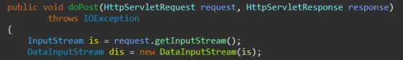

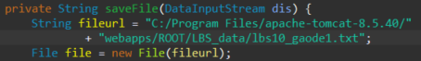

1. Configure web.xml and Index.jsp:





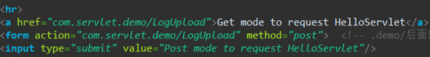

1. Configure the upload URL path of this Android Application according to Tomcat's IP address [3]:





## Use Gaode Map’s SDK in Android application

Gaode Map Android SDK is a set of Map development calling-interface. Developers can easily add Map-related functions to their Android applications, including Map display (including indoor and outdoor Maps), Map interaction, Map drawing, interest point search, geocoding, offline Maps and other functions [15].

Thermodynamics provides the ability to display business data on Maps, which can give users an intuitive description of the heat of people, vehicles and other things in a region [7].

Locating blue dots refers to the function of displaying the current position points after entering the Map.

1. Configure Android Manifest. XML [1]:



1. Apply for and set up Golden Key:



1. Add Map Development Kit to Android Application:

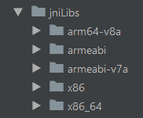

1. Initialize the Map container and display the Map:



1. Organizational thermographic data. SDK thermographic data need longitude and latitude point array/list data (read the content of location information file, use regular expression to extract longitude and latitude):

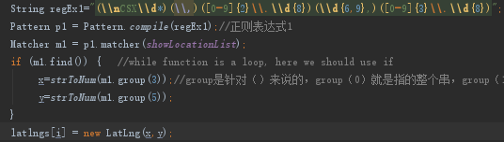

1. Building HeatMapTileProvider. HeatMapTileProvider is the core class of generating thermograms:



1. Draw thermographic layers. Draw thermographic layers by Tile Overlay:



1. Realizing Blue Point Location and Modifying Its Parameters:



## Debug and Refine Android application

After making the preliminary software, according to the new requirements put forward by the product manager and the necessary optimization of the page layout, the following optimization is made.

1. Adding new activities and pages to better show the results of Map visualization:



1. Modify the default application icon, page background and layout:

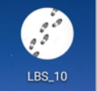 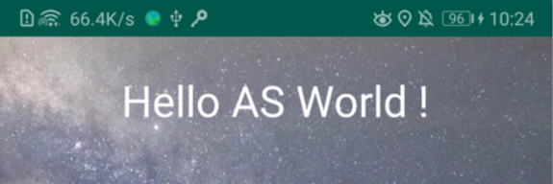

1. Adding and displaying dynamic pictures. Displaying pictures while performing the task of uploading files:



1. Set the text view display box on the main page to get the latest location information, and can clearly observe whether the software is running properly:

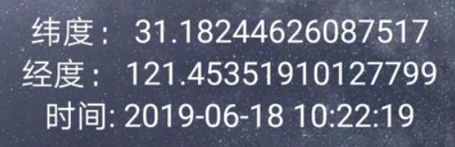

## Result

After debug and refine, the application’s pages are:

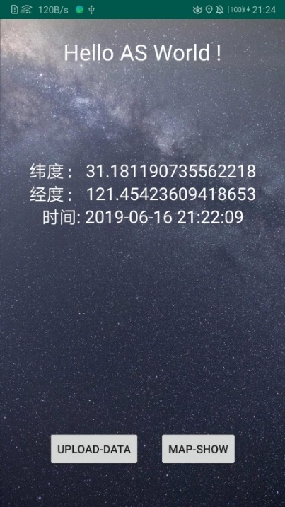 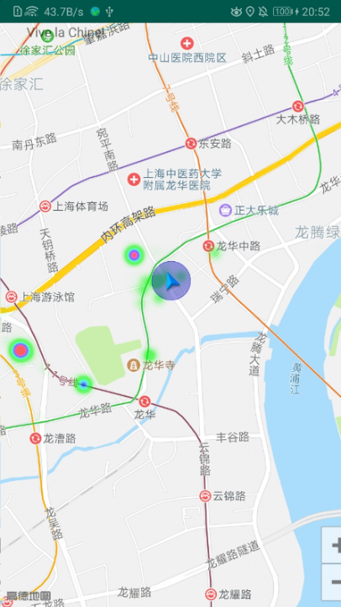

Figure 8: Application's main page Figure 9: Gaode Map Visualization

Figure 8 is the main interface of the application. There are two buttons: "UPLOAD-DATE" and "MAP-SHOW". Click the "UPLOAD-DATE" button to upload the data files stored in the mobile phone to the local server. Click the "MAP-SHOW" button to display the interface of Figure 9. In the interface of Figure 8, the blue marker is the current location of mine, and the circle is the location range (because the location is inaccurate in large buildings). The green circle indicates that there has been more than one location record. The green circle with a red center means that there are many records of location. The red center at the bottom left is my residence, and the red center at the top right is the restaurant near the company. Because of the inaccurate positioning in the company, there is no red center at the company's location.

# Test and Status of in-use

## Test

After completed the project development on AS, install it on Android mobile phone. In the test, we used two Android mobile phones: Glory 9, API: 28, as the terminal of software operation. Another mobile phone opened the hotspot function to provide LAN network services for the testing machine. Two laptops (one is my computer: computer A, which can access websites without restrictions. The other is the company's computer: computer B, which has certain restrictions on access to the external network).

Beginning testing on June 17, 2019, the software has been running on Android phones for some time and is expected to accumulate more than 1,000 location information records.

1. Open CMD with computer A, write the command "startup", then Tomcat local server is activated.
2. Open the browser to visit Tomcat's home page: http: // 192. 168. 43. 222: 8080/. Click on server state, click on the user-defined account number and password. Tomcat server runs successfully.
3. With mobile A, open the software, the main page shows the location information obtained last time. Click on the "upload-data" button, the main page shows the loading effect. Check the local memory of Android mobile phone, could find that the last editing time of lbs10_gaode1.txt is 10:12 a.m:

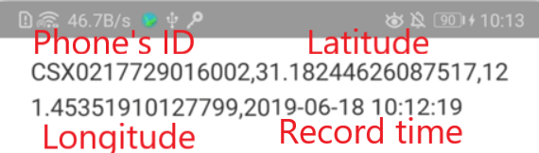

1. Check the local memory path in computer A and find the uploaded files. The latest editing time is 10:12 a.m. too:

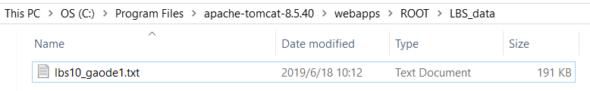

1. Use Computer B to connect the Wi-Fi of mobile phone B, input the relative path of data files in the server in the browser, and open the file successfully. Computer B can save this file locally:

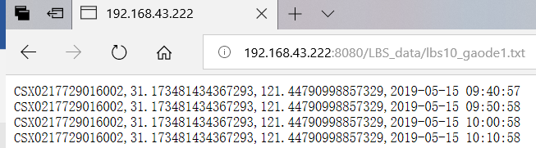

After these test steps, prove that this project could transfer data from mobile phone A to computer B. Then, computer B can process the location data information and further visualize data on the web page.

## Status of in-use

The status in-use environment of this application is an Android mobile phone, which installs the application by saving packaged APPLICATION files on the mobile phone and opening APPLICATION through the file manager attached to the mobile phone. Mobile phone: Honor9, Android 9, screen resolution: 1920*1080, API:28.

After running for 15 days, check the content of location information memory file. Display and record about 1500 records, the success rate of getting location information on time is 70%. The reasons of unsuccessful acquisition of location information are as follows:

1. When the application runs in the background, the request for location information may be delayed due to the process management of Android system, such as these records:

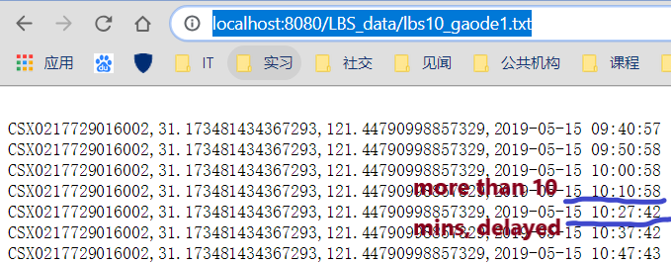

2. Because there are almost no mobile network signals and GPS positioning is invalid in large buildings. The location information is not obtained at the time point when the location information is acquired by time. So, there is no data recorded [4].

3. Turn off the location information button of mobile phone occasionally.

4. Process blockage caused by poor application design.

# Conclusion

## About what I've done and will do

In the first stage of this internship (April-May), the project tasks arranged by the leader of department were accomplished. There are 4 goals of this project:

1. To achieve a simple operation page;
2. The visualization effect of built-in information that can continuously collect location information;
3. To localize and save data information;
4. To upload these files for further process.

The implementation of these goals provides engineering reference value for future Android SDK development even this product.

In the remaining part of the internship (June-early August), I plan to study and carry out data feature processing, as well as further algorithm implementation. The feature extraction and feature value judgment of insurance information is carried out.

## About what I have learnt except for working experience

During the internship, I gained a lot of new knowledge and insights.

1. In terms of work, I recognize that there are many differences between doing projects in the company and in school. For example:

A. In a company's project, we need to consider the limitations of various objective situations, such as the company's computer network access and file transfer restrictions.

B. Projects made should be of direct use value. For example, this software is designed to carry out the research work of a product. After successful software development, there will be a professional development team to carry out the product development work.

C. Division of labor and cooperation with colleagues. Because everyone has multiple tasks at the same time (I have several temporary tasks in the past two months, processing many temporary data, investigating the use of a software, writing OCR open source software Tesseract usage and development process report), it needs to be patiently arranged and waited together. Job opportunities.

2. Personally, it is found that the use of time outside work determines the quality and happiness of life.

A. Occasionally work overtime for an hour or two to learn the techniques used in the project.

B. After work, I go to the company gym three times a week for half an hour to an hour.

C. Other evenings and weekends will be used for reading (Godfather 2&3, the descent of woman, recently read Camus's L'Etranger, reading Milan Kundera's L'Immortalite). Chat with relatives and friends.

D. Travel on vacation to explore unknown cities and new world.

In a word, I quite enjoy this summer internship. Thanks for the internship arrangement made by the school.

Thanks for your time. Thank you.

# References

* 1. Jackson, Wallace . Introduction to XML: Defining Android Apps, UI Design, and Constants. Android Apps for Absolute Beginners. Apress, 2017.
  2. Twigg, and R. D. . "OSGB36/WGS84 COORDINATE TRANSFORMATIONS." Survey Review 35.275(2000):292-306.
  3. Lin Yuman, et al. "SDK Design for Simplifying HTTP Connections in Android Environment." Computer Knowledge and Technology: Academic Exchange (2018).
  4. Li W., Lu D. (2012) The Application of LBS Based on Android. In: Lei J., Wang F.L., Li M., Luo Y. (eds) Network Computing and Information Security. NCIS 2012. Communications in Computer and Information Science, vol 345. Springer, Berlin, Heidelberg
  5. ZHOU-Bing. "Interaction between UI Thread of Android and Background Thread." Journal of Yunyang Teachers College(2013).
  6. Dimarzio, J F . "ANDROID A PROGRAMMERS GUIDE." (2016).
  7. Pryke, Andy , S. Mostaghim , and A. Nazemi . "Heatmap Visualisation of Population Based Multi Objective Algorithms." EMO 2007 Springer-Verlag, 2007.
  8. Brittain, Jason , and I. F. Darwin . Tomcat the Definitive Guide. Tomcat: The Definitive Guide. O'Reilly Media, Inc. 2003.
  9. Wang, Chao , et al. "The research of Android System architecture and application programming." International Conference on Computer Science & Network Technology IEEE, 2012.
  10. Hagos, Ted . "Android Studio." (2018).
  11. Ping An company profile: <http://www.pingan.cn/en/about/overview.shtml>
  12. OneConnect company profile: <http://www.oneconnectft.com/index.php?s=en/about_introduce.html>
  13. Smartphone Market Share: <https://www.idc.com/promo/smartphone-market-share/os>
  14. Baidu Wikipedia: <https://baike.baidu.com/item/tomcat/255751?fr=aladdin>
  15. Gaode Open Platform: Map <https://lbs.amap.com/getting-started/map>